# CS 255 System Design Document

## UML Diagrams

### UML Use Case Diagram

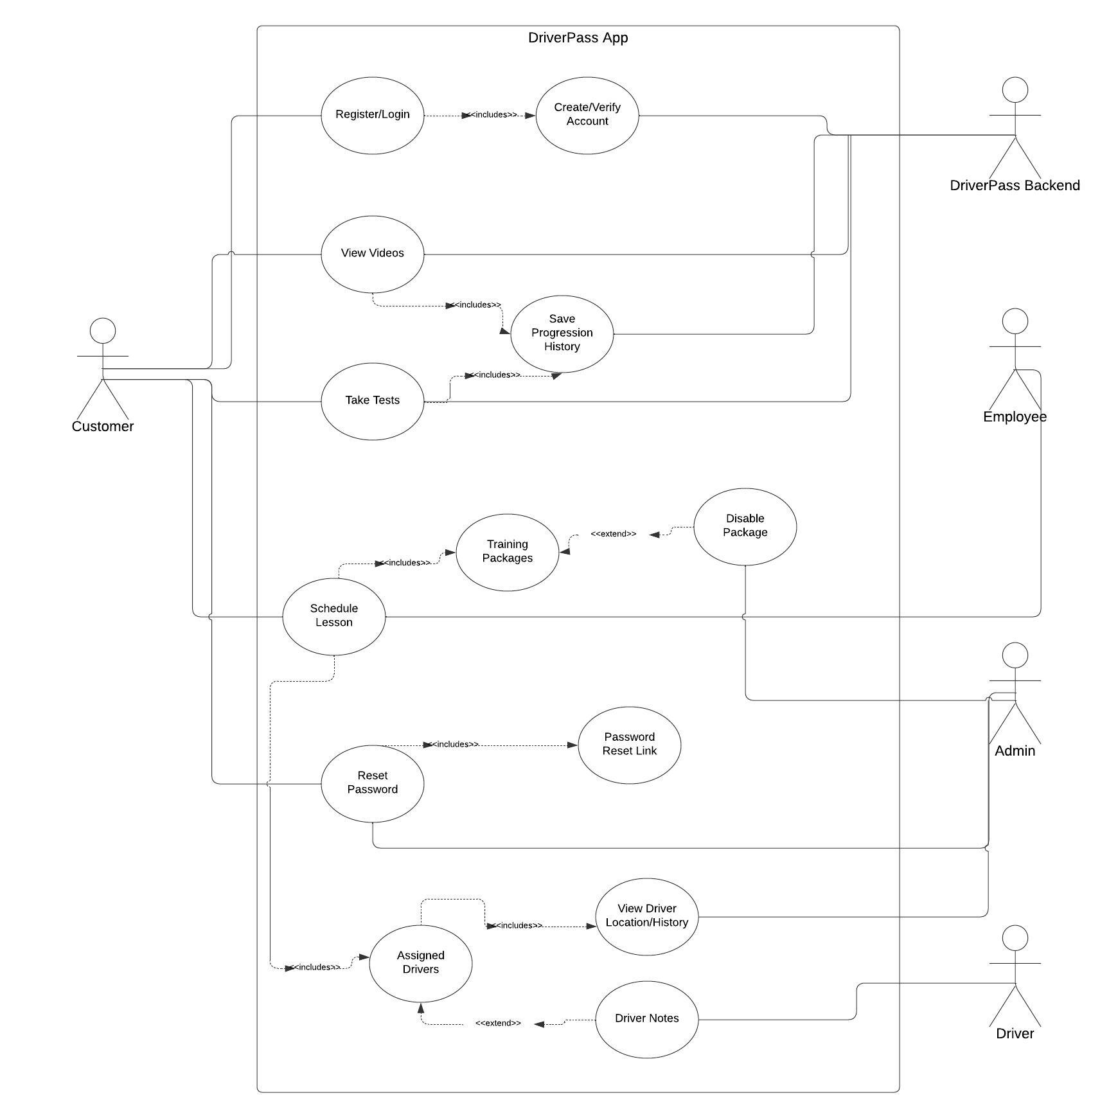

### UML Activity Diagrams

*Reset Password Activity Diagram:*

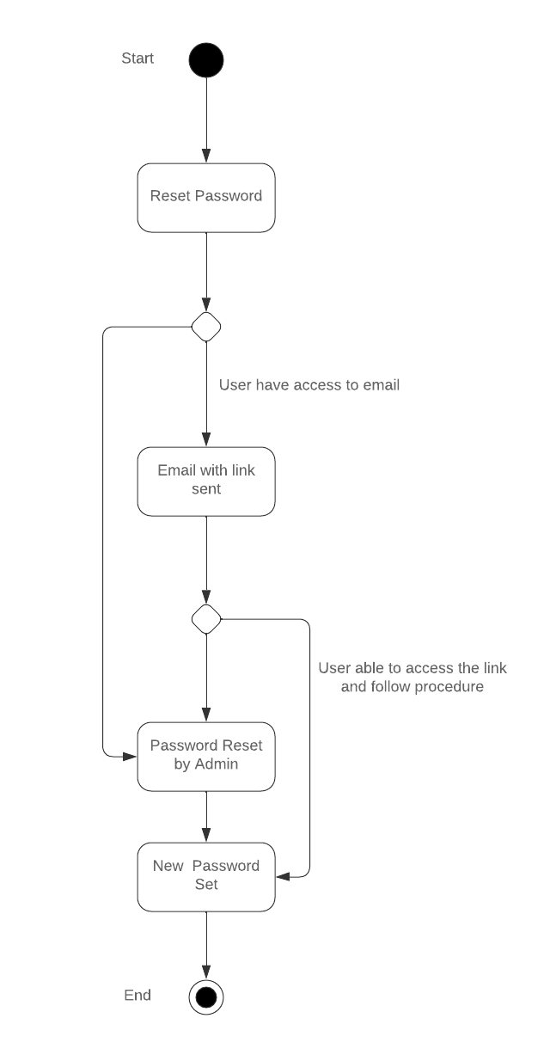

*Schedule Lesson Activity Diagram:*

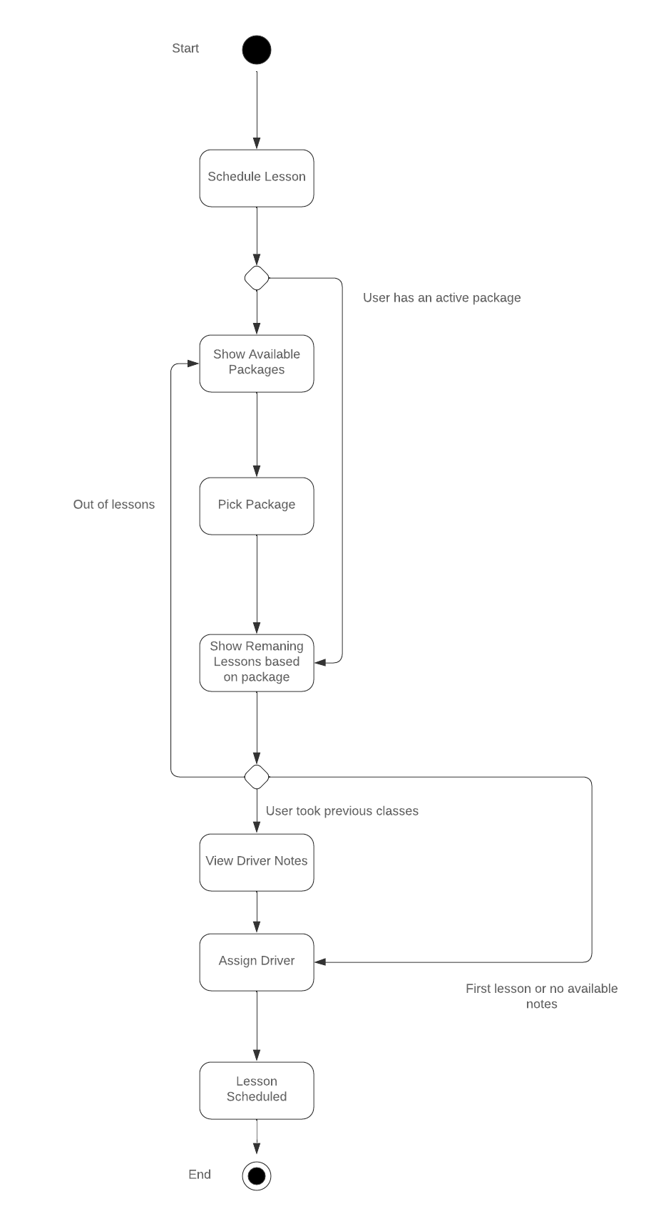

### UML Sequence Diagram

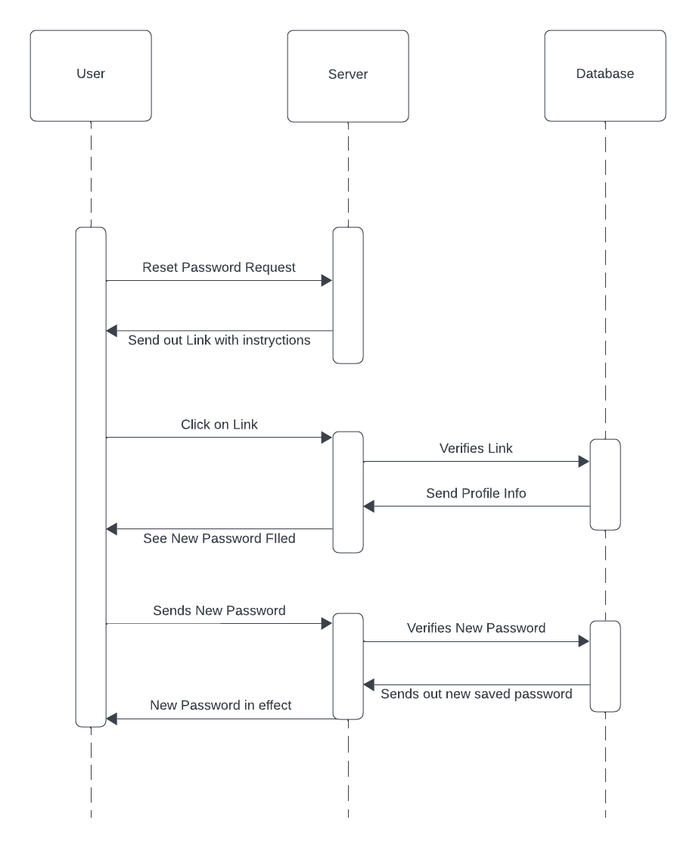

### UML Class Diagram

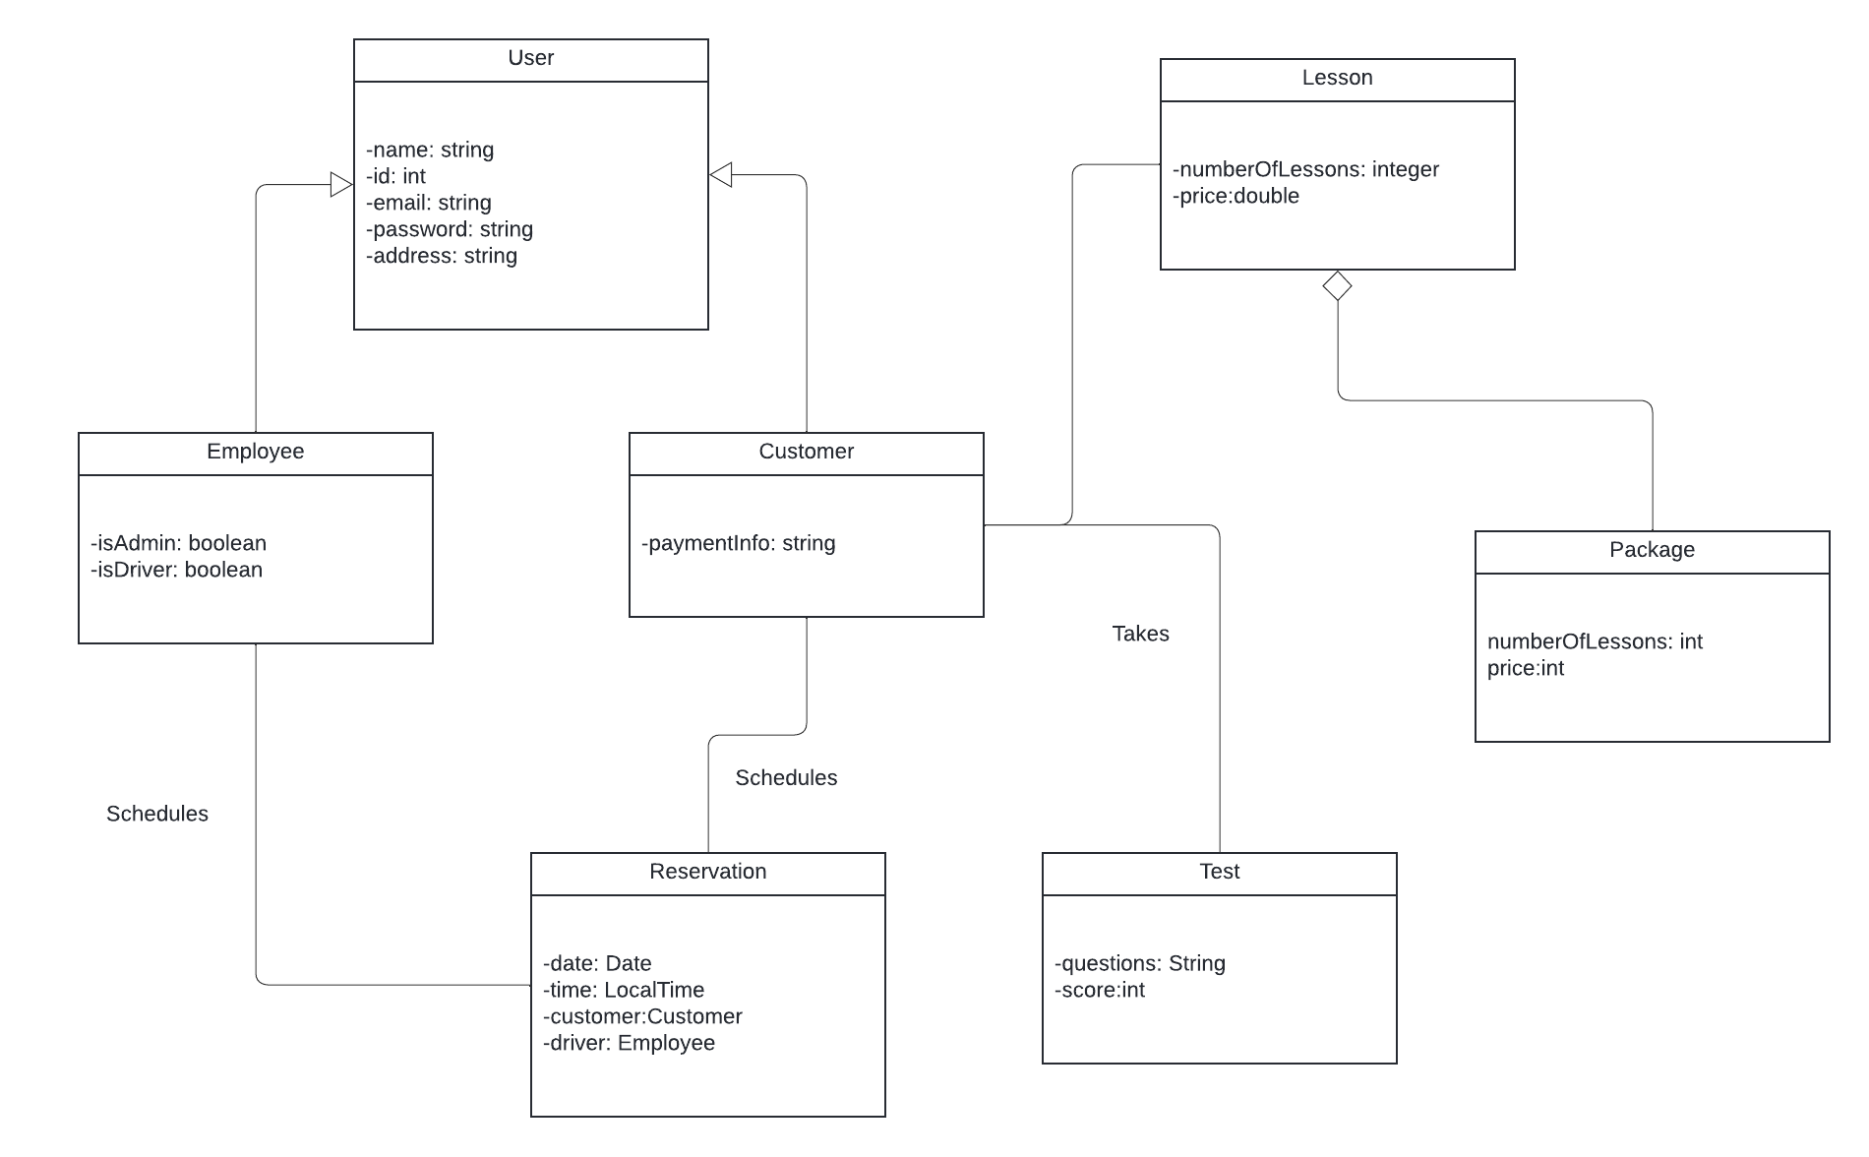

## Technical Requirements

DriverPass has two major technical requirements: a server component that hosts the app and handles the data, and the end user devices used to access the app such as phones and computers. On the software end – Java will be the core programming language, and Spring Boot the framework for backend development. DriverPass will also rely on a MySQL database to store user data, lesson/package details and information, and driver performance records. It will also use a cloud-based platform such as AWS or Microsoft Azure, for their scalability, security, and storage capabilities. DriverPass will also incorporate third-party APIs, such as the Google Maps API, so driver/user location and routes are tracked in real time during classes to ensure compliance and safety. Lastly, development tools like IntelliJ IDEA or Eclipse will be used for coding. I would also use Github for version control and engaging collaboration amongst the other developers.

In order to have smooth functionality, the infrastructure component will need a few things: a high speed and reliable internet connection, a secure communication protocol like HTTPs, and a reliable server that can guarantee 24/7 available and limited downtime. I will have a multi-layered protection for the security framework. This would include firewalls, encryption techniques, and role-based access controls for safeguarding of user data. I will also use automated testing tools to ensure the reliability of the software. On the cloud side – the integration of APIs and the proper scaling mechanisms will make sure DriverPass is able to handle any peak traffic and high data loads without significant performance degradation.